**Main Page:-**

Enter the URL: <http://localhost:8080/tickets>

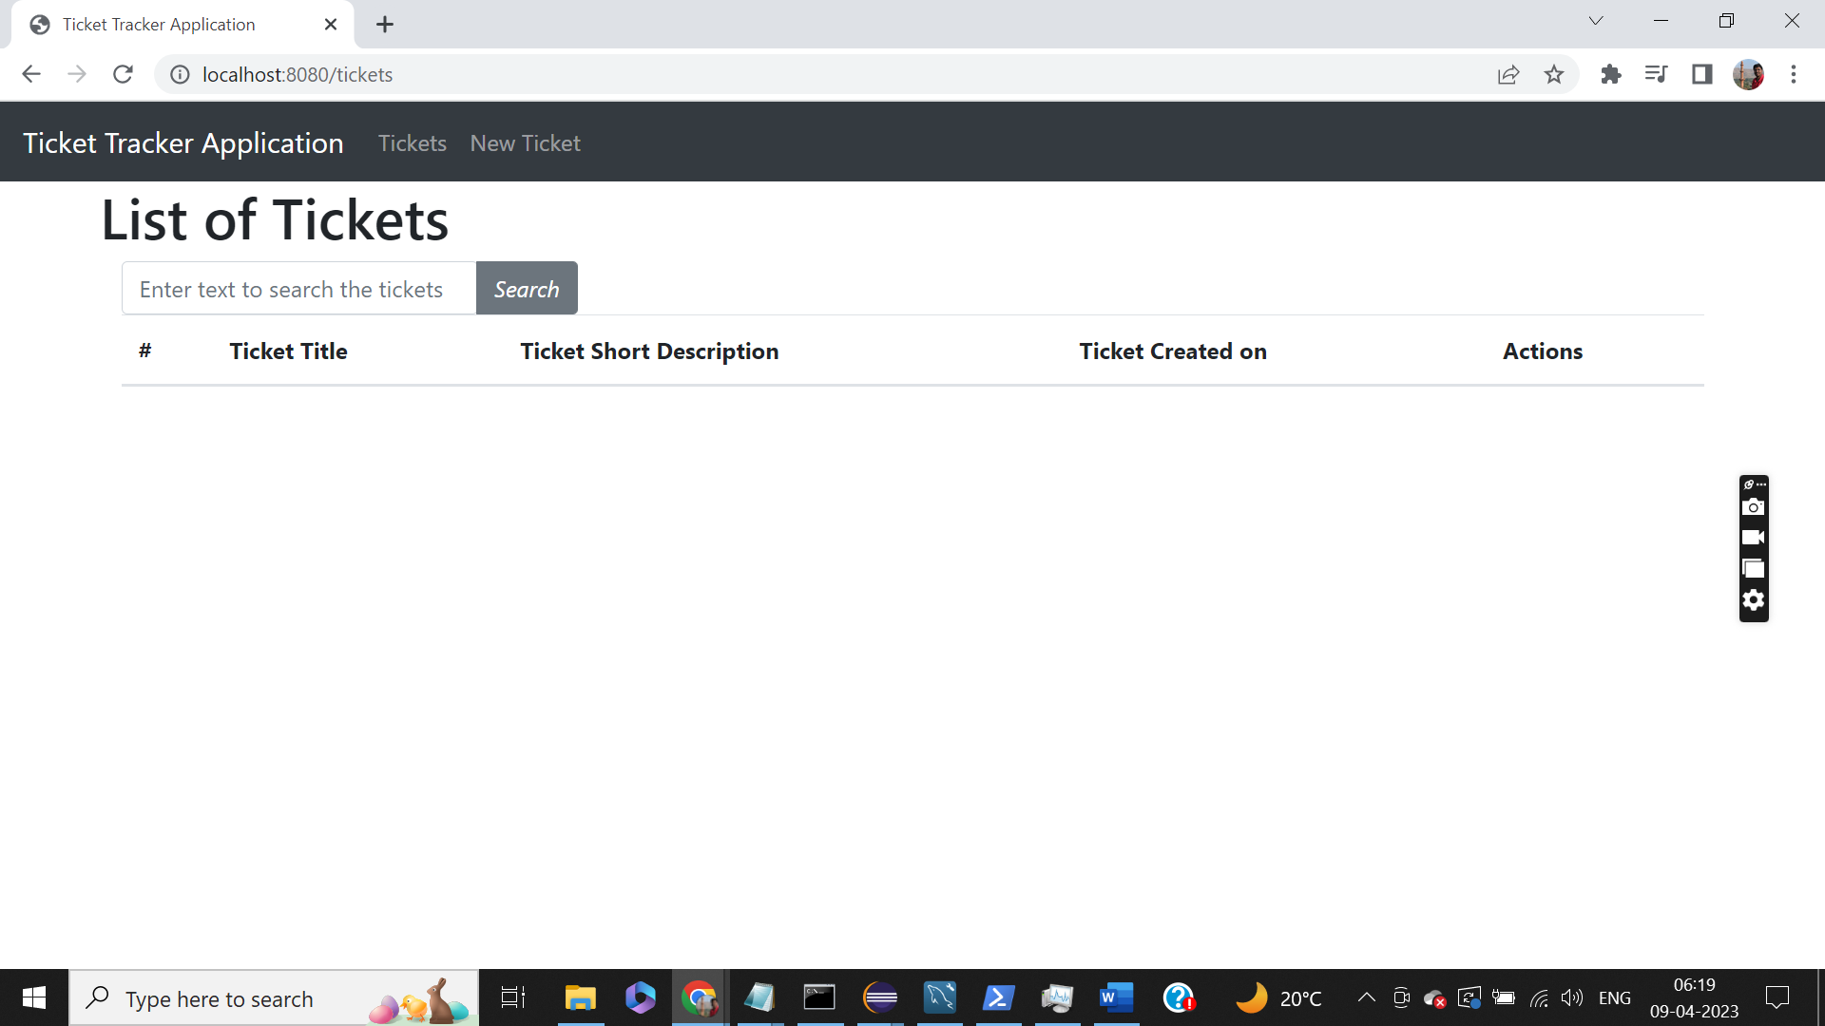

Create New Ticket:-

On click of “New Ticket” the Create ticket screen appears.

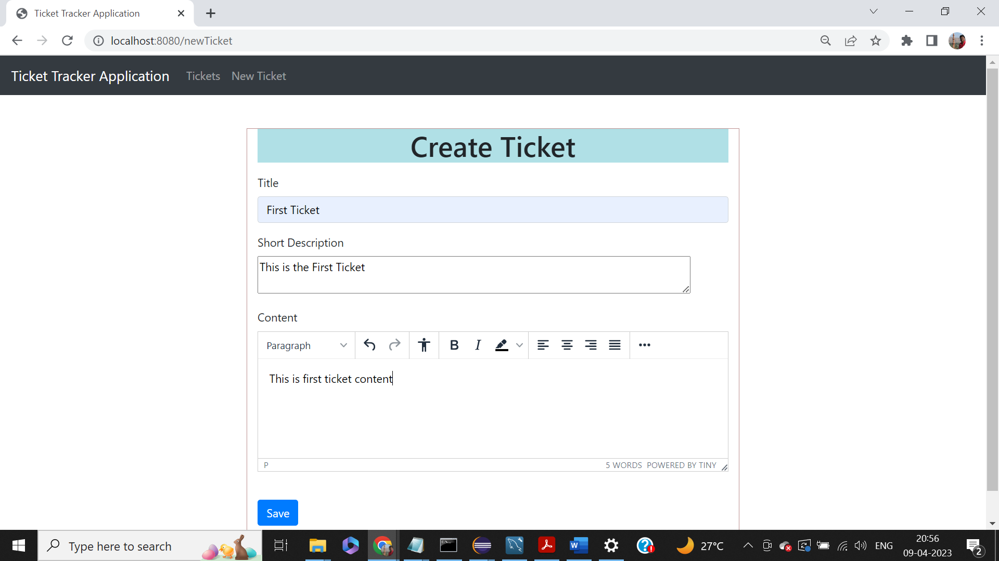

After a ticket is created, the flow it directed to “List of Tickets” screen.

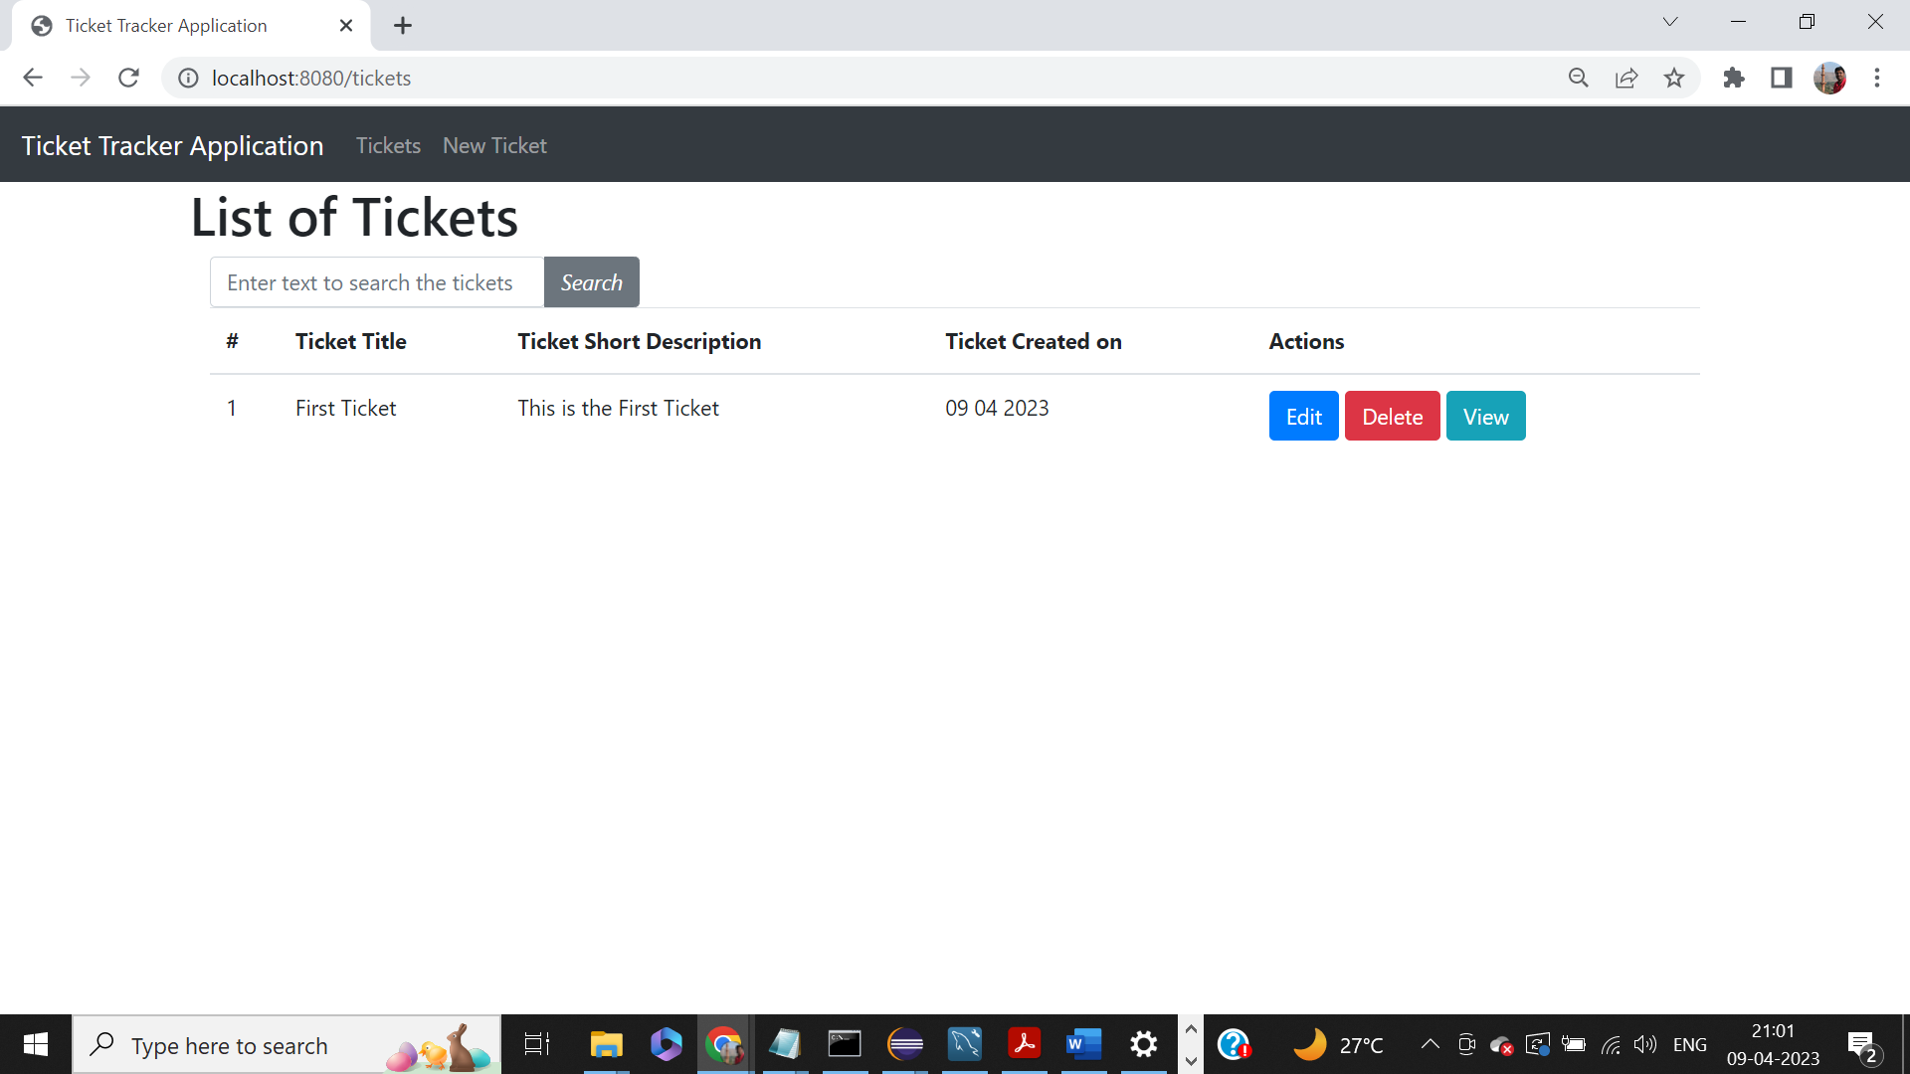

Click View to see the existing ticket details.

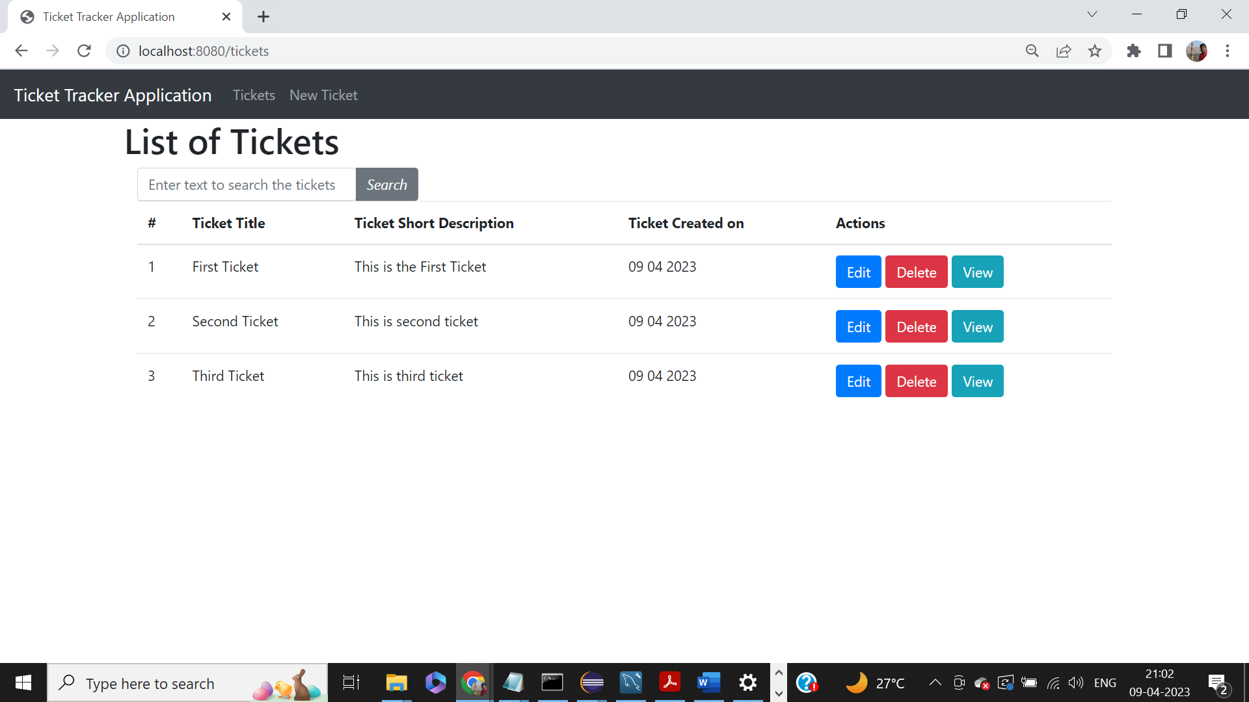

View Ticket Screen:-

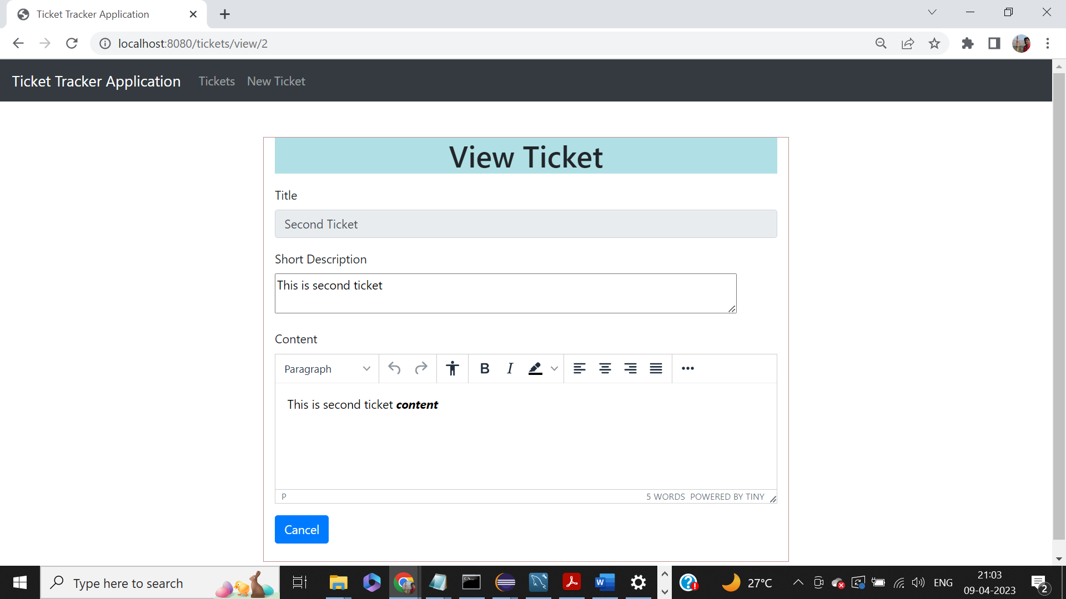

On click of edit the “Edit Ticket” screen appears, we can make the necessary changes and click save to update the ticket details.

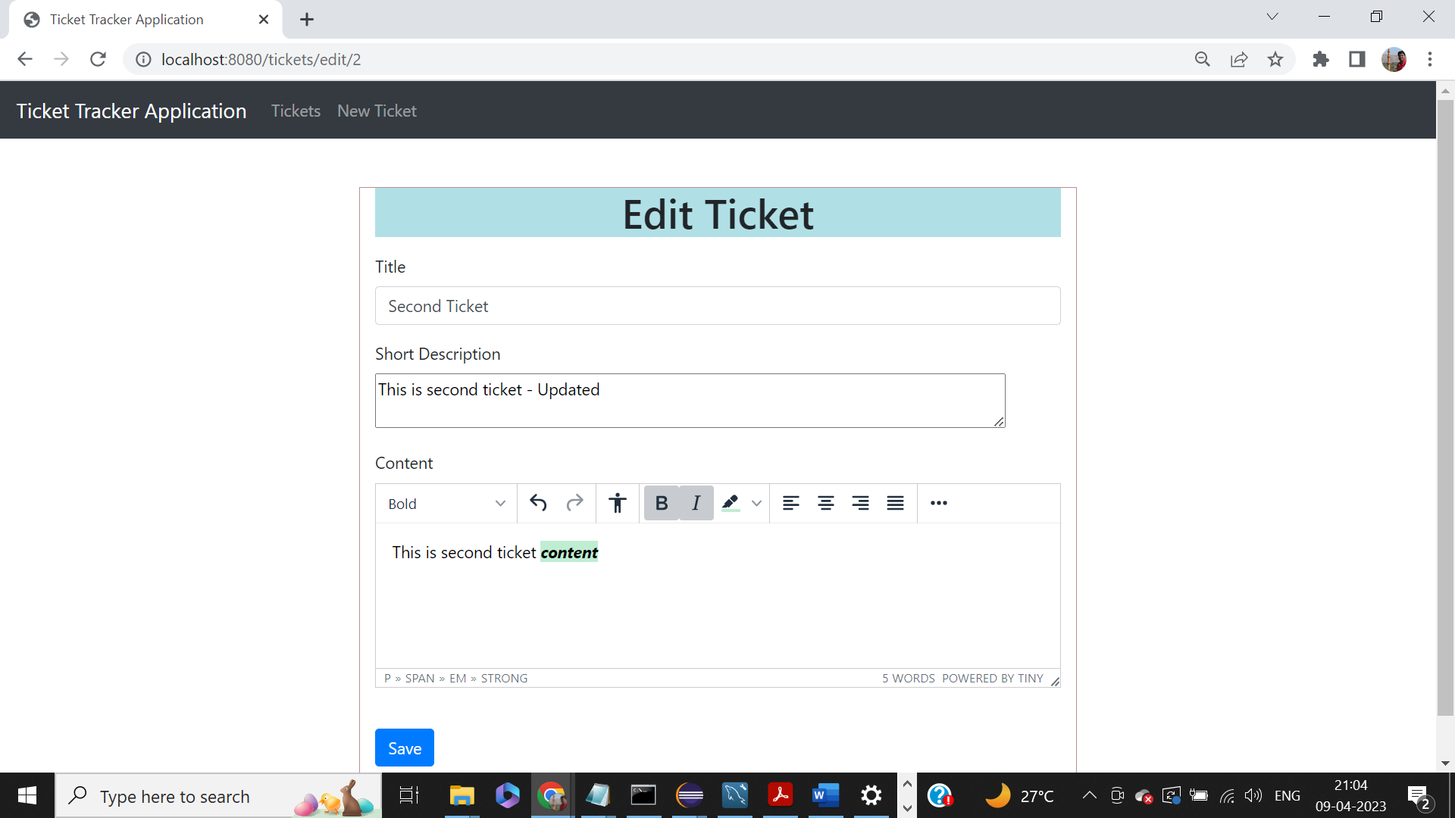

On click of “Save” in the edit screen the tickets list screen appears with updated details.

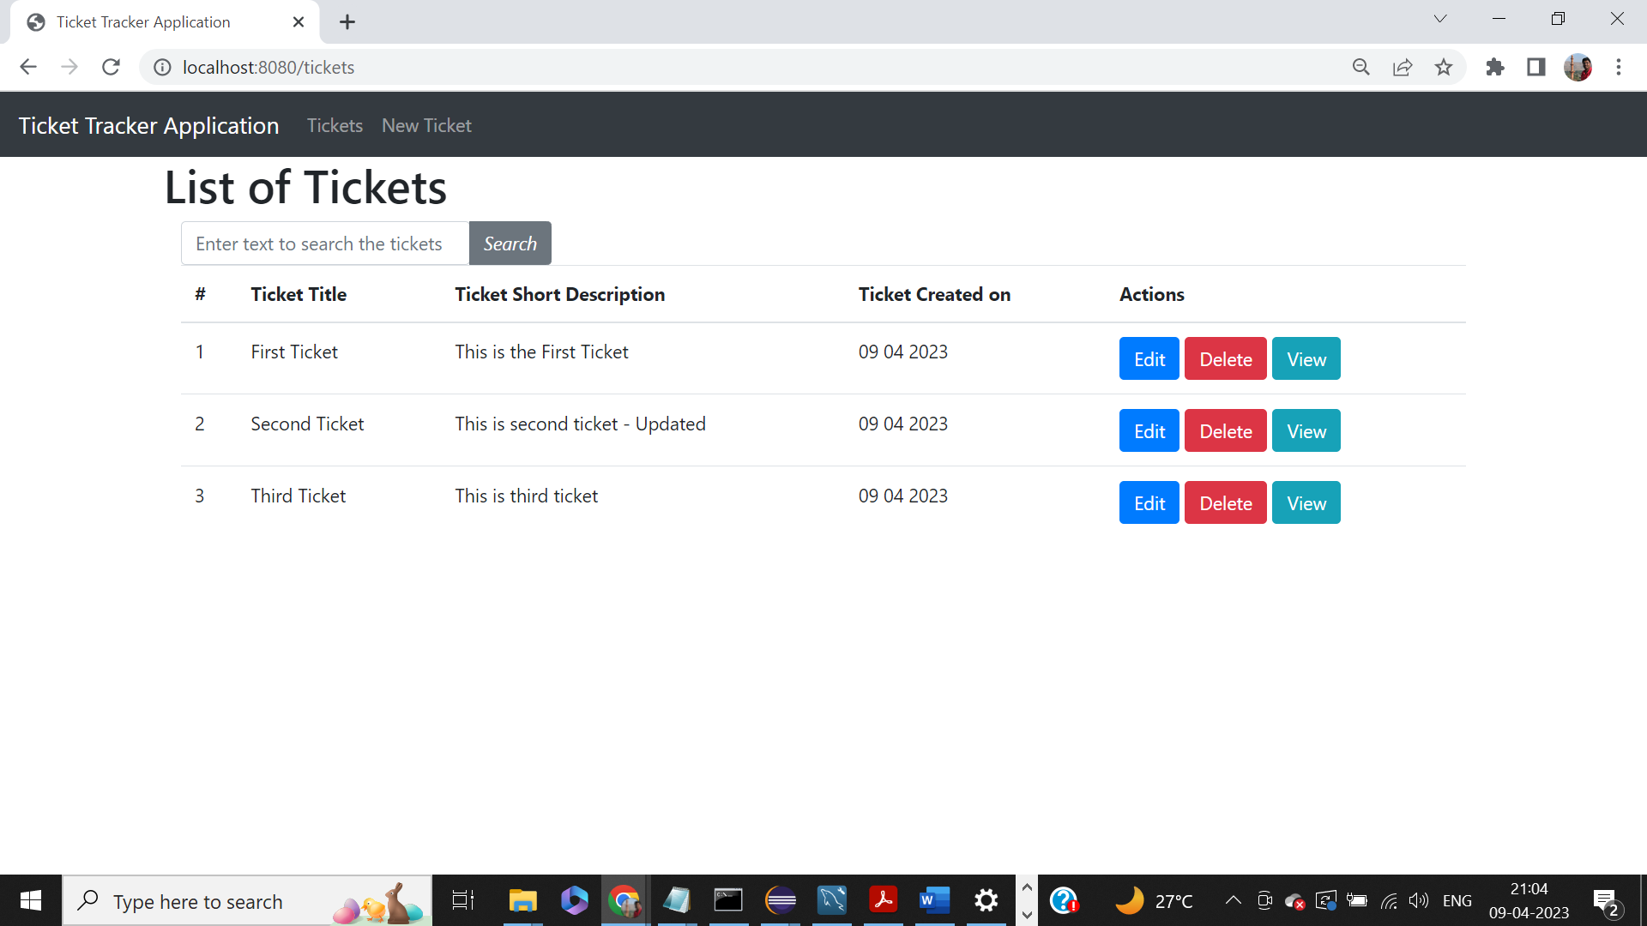

Delete Operation:- Click the delete button to delete the record.

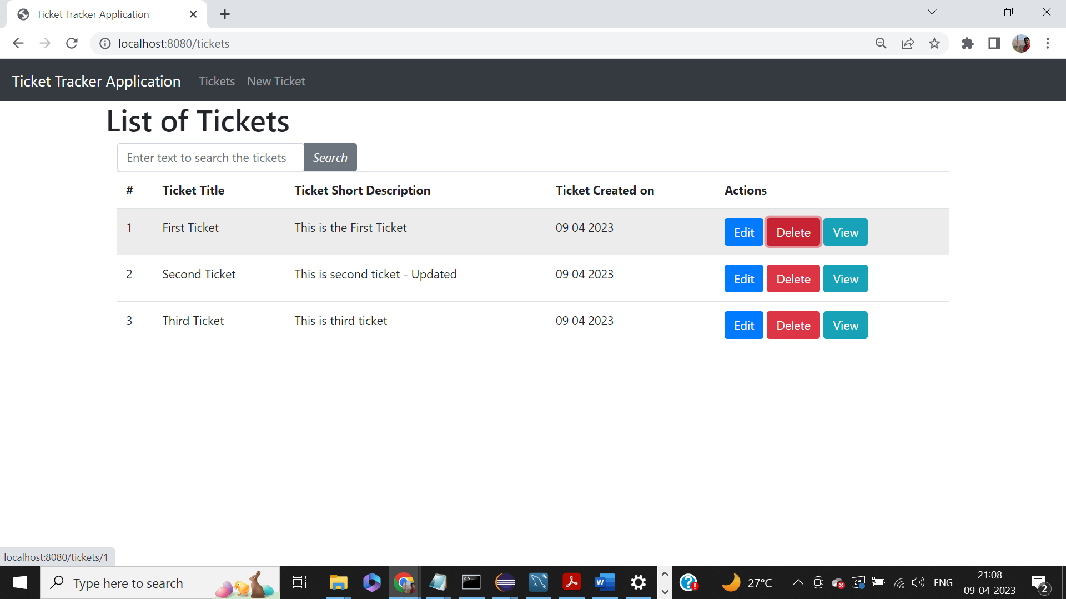

Post deletion, the updated list of tickets appears in the screen.

